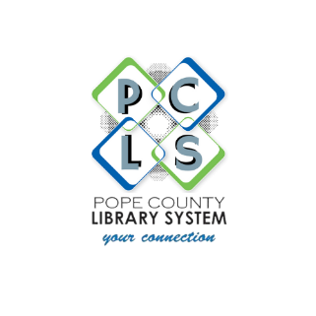
Pope County Library System

Mary Ella Yamashita
Marketing Librarian
(479) 968-4368, ext. 212
myamashita@popelibrary.org

9/10/24
FOR IMMEDIATE RELEASE:
POPE COUNTY LIBRARY SYSTEM ADDS ONLINE ACCESS TO FREE
DEPARTMENT OF MOTOR VEHICLES (DMV) PRACTICE TESTS

Russellville, Arkansas: The popular driver education platform, Driving-Tests.org, is now available for free from the Pope County Library System’s website at popelibrary.org/teens/about-our-teens. Patrons can use the Driving-Tests platform to prepare for their DMV knowledge exam. The program is designed to help aspiring as well as more experienced drivers (teens, newcomers, renewal applicants or senior citizens). Tests can be accessed from any computer or mobile device.
Driving-Tests provides Pope County library patrons with unlimited access to official Arkansas state driver’s manuals; online practice tests for car, motorcycle and commercial driver’s license (CDL); an exam simulator; and a DMV-related FAQ. In addition to being the largest and most visited independent online driver education provider in the United States, Driving-Tests helps patrons pass their driving knowledge test faster and more effectively; prospective drivers who take the practice tests and read the official manual are 73% more likely to pass than those who study the manual alone.
Edna Smith, Pope County Library Young Adult Services Librarian says, “The ability to access the drivers' practice test from our library homepage is such a great addition to our existing collection of study guides and homework help for our teens!”
The Driving-Tests collection includes access to a DMV office finder; beginner driver’s guide; virtual assistant; and Challenge Bank—a special test that stores the user’s wrong answers from taking practice tests.
Driving-Tests was founded in 2010 by CEO Andrei Zakhareuski as an educational platform to empower people to increase their knowledge of how to be safe behind the wheel. Over 46 million Americans have passed their DMV knowledge test by using the platform.
###

