May 24, 2023

Arkansas State University-Mountain Home Chancellor Finalists Named
MOUNTAIN HOME, Ark. – The Arkansas State University-Mountain Home Chancellor Search Advisory Committee and ASU System President Dr. Charles L. Welch today announced that three finalist candidates have accepted invitations to visit the campus and formally interview for the position of chancellor.

The three finalists are:
- Dr. Kendra Ericson, president of St. Luke’s College in Sioux City, Iowa
- Dr. Tamara Daniel, provost and vice chancellor for academic affairs at ASU-Mountain Home
- Dr. Bentley Wallace, president of South Arkansas College in El Dorado
The invitations to formally interview on campus come after recent meetings Welch conducted with the Chancellor Search Advisory Committee. The advisory committee, consisting of 12 members representing faculty, staff, students, and community representatives, reviewed 47 applications for the position.
“We’re very pleased with the pool of quality applicants, and the three finalists are outstanding higher education administrators with impressive backgrounds who would each bring unique experiences to ASU-Mountain Home,” Welch said. “We look forward to interviews and constituency visits on campus during the next couple of weeks, and we will welcome feedback.”
Each finalist will meet with the advisory committee, faculty, staff, students, and community members during interview sessions on June 5 with Ericson, on June 6 with Daniel and on June 7 with Wallace. Individuals attending the interview sessions will have an opportunity to submit feedback regarding each candidate to the Chancellor Search Advisory Committee. Following the final interview, the advisory committee will meet to discuss the candidates and provide feedback to Welch.
Welch has indicated a desire to name a new chancellor by July 1, 2023.

The Finalists

Dr. Kendra Ericson
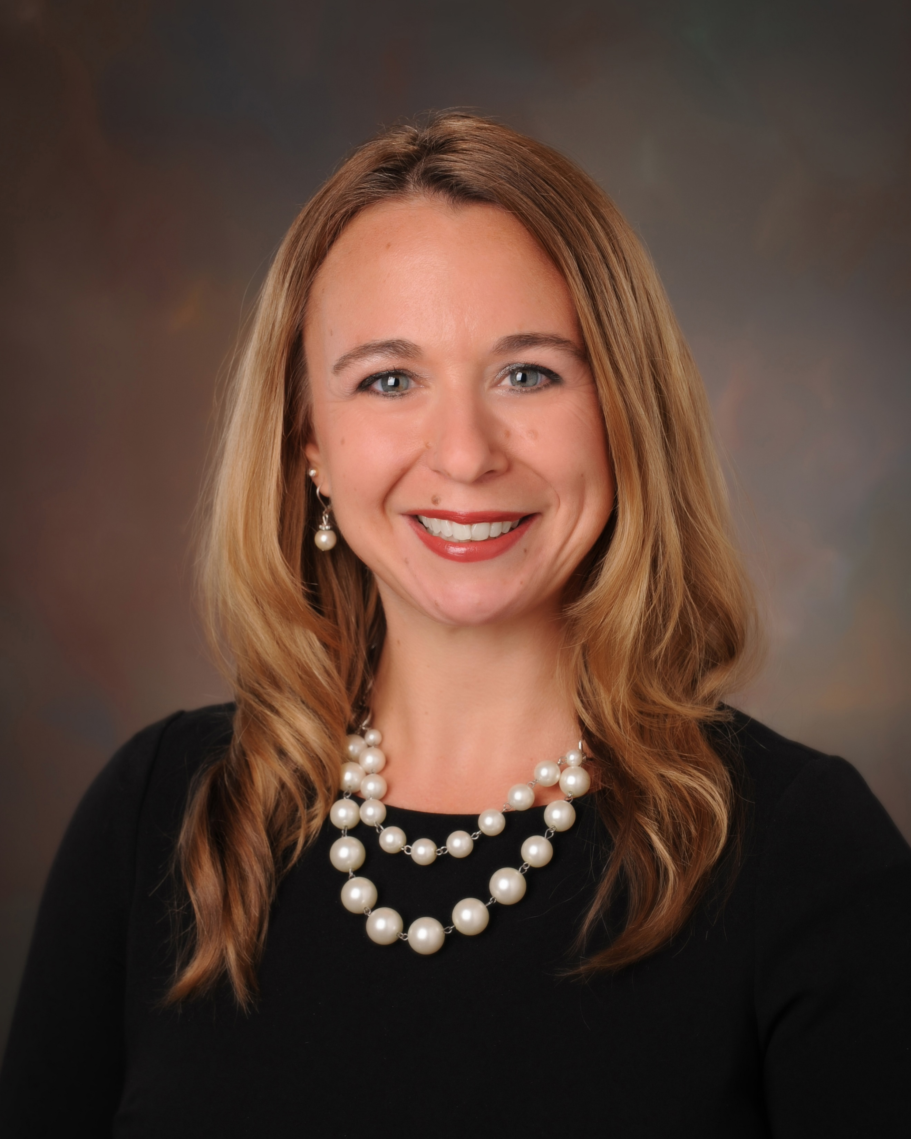

Dr. Ericson has been president of St. Luke’s College, a private, not-for-profit health-based college in Sioux City, Iowa, since January 2020. From 2013-2020 she was director of nursing education at Des Moines Area Community College in Ankeny, Ia. She was director of nursing at LeTourneau University in Longview, Tx., from 2010-2013.
Education: Ph.D., Nursing, University of Missouri-Kansas City; M.S., Nursing, University of Phoenix; B.S., Nursing, Trinity College of Nursing Moline; A.S., Nursing, Trinity College of Nursing Moline.

Dr. Tamara Daniel

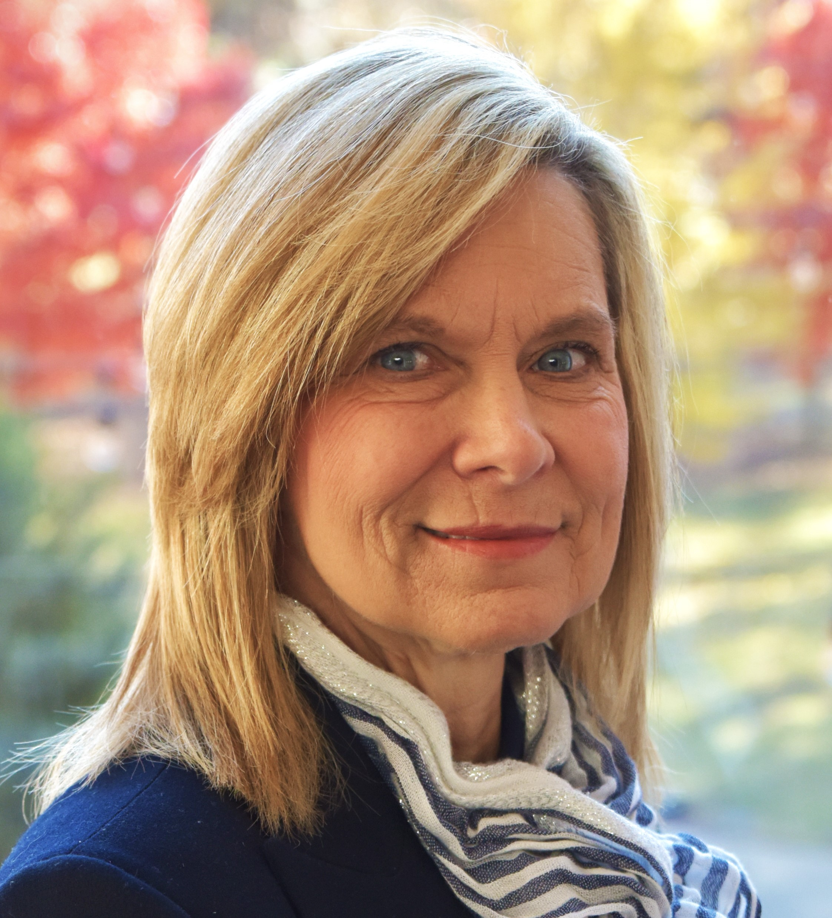
Dr. Daniel has been provost and vice chancellor for academic affairs at ASU-Mountain since August 2019. She was vice president at Dyersburg State Community College in Tennessee from 2017-2018. She served in multiple roles – including associate dean of academic affairs, mathematics department chair and international studies director – between 2008-2017 at Southwest Tennessee Community College in Memphis.
Education: Ph.D., Mathematics, University of Mississippi; M.S., Mathematics, University of Mississippi; B.A., Psychology, University of Mississippi.

Dr. Bentley Wallace

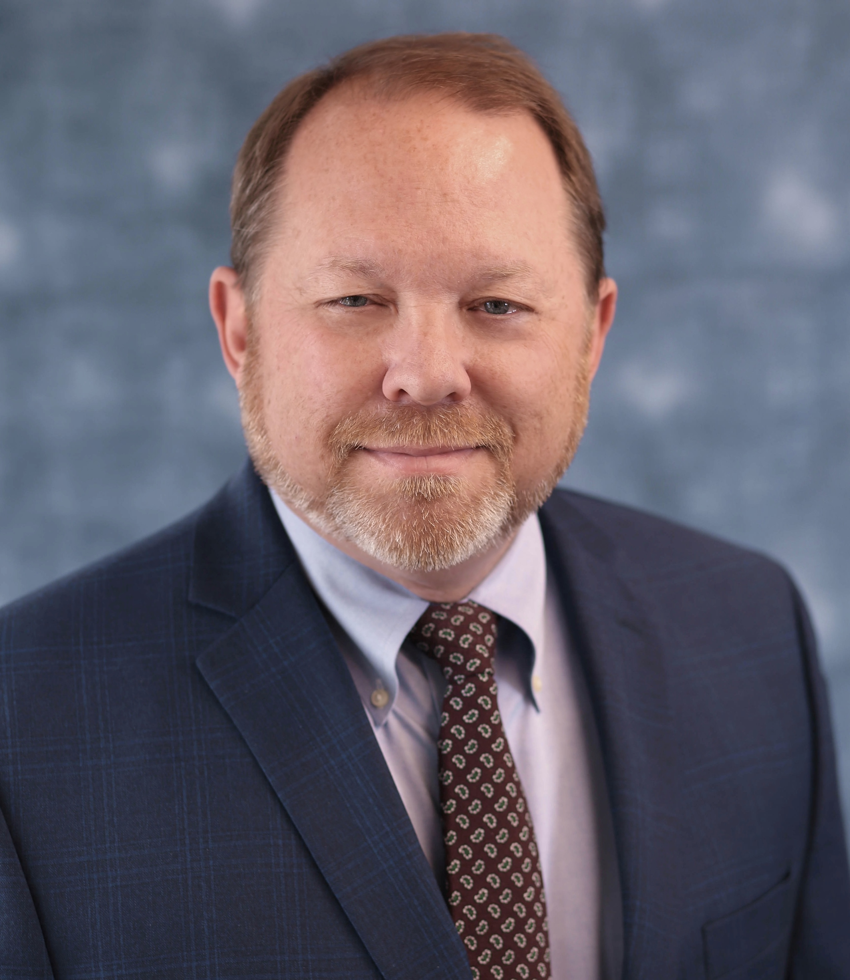
Dr. Wallace has been president of South Arkansas College in El Dorado since 2020. Between 2013-2020, he served as vice chancellor for economic development and dean of the School of Technical and Professional Studies at University of Arkansas Pulaski Technical College in North Little Rock. He was division chair and director of business and transportation technology at ASU-Newport from 2006-2013.
Education: Ed.D., Human Resource and Workforce Development Education, University of Arkansas; M.S., Education, Arkansas State University; B.S., Marketing, Arkansas State University.

