BID RESPONSE PACKET
ASUMH RFP 2023-02

BID SIGNATURE PAGE

Type or Print the following information.
PROSPECTIVE CONTRACTOR’S INFORMATION
Company:
Address:
City: |  | State: |  | Zip Code:
Business  Designation: | ☐ Individual ☐ Sole Proprietorship ☐ Public Service Corp  ☐ Partnership ☐ Corporation ☐ Nonprofit
Minority and  Women-Owned  Designation*: | ☐ Not Applicable ☐ American Indian ☐ Service Disabled Veteran  ☐ African American ☐ Hispanic American ☐ Women-Owned  ☐ Asian American ☐ Pacific Islander American
 | AR Certification #: _______________ * See Minority and Women-Owned Business Policy

PROSPECTIVE CONTRACTOR CONTACT INFORMATION
Provide contact information to be used for bid solicitation related matters.
Contact Person: |  | Title:
Phone: |  | Alternate Phone:
Email:

CONFIRMATION OF REDACTED COPY
☐ YES, a redacted copy of submission documents is enclosed.
☐ NO, a redacted copy of submission documents is not enclosed. I understand a full copy of non-redacted submission documents will be released if requested.
Note: If a redacted copy of the submission documents is not provided with Prospective Contractor’s response packet, and neither box is checked, a copy of the non-redacted documents, with the exception of financial data (other than pricing), will be released in response to any request made under the Arkansas Freedom of Information Act (FOIA). See Bid Solicitation for additional information.
ILLEGAL IMMIGRANT CONFIRMATION
By signing and submitting a response to this Bid Solicitation, a Prospective Contractor agrees and certifies that they do not employ or contract with illegal immigrants. If selected, the Prospective Contractor certifies that they will not employ or contract with illegal immigrants during the aggregate term of a contract.
ISRAEL BOYCOTT RESTRICTION CONFIRMATION
By checking the box below, a Prospective Contractor agrees and certifies that they do not boycott Israel, and if selected, shall not boycott Israel during the aggregate term of the contract.
☐ Prospective Contractor does not and shall not boycott Israel.

An official authorized to bind the Prospective Contractor to a resultant contract must sign below.

The signature below signifies agreement that any exception that conflicts with a Requirement of this Bid Solicitation will cause the Prospective Contractor’s bid to be disqualified:

Authorized Signature: | Title:
Printed/Typed Name: | Date:

SECTIONS 1 - 4 VENDOR AGREEMENT AND COMPLIANCE

- Any requested exceptions to items in this section which are NON-mandatory must be declared below or as an attachment to this page. Vendor must clearly explain the requested exception and should label the request to reference the specific solicitation item number to which the exception applies.

- Exceptions to Requirements shall cause the vendor’s proposal to be disqualified.

Vendor Name: |  | Date:
Printed Name: |  | Title:
Signature:
By signature below, vendor agrees to and shall fully comply with all requirements as shown in the bid solicitation.

PROPOSED SUBCONTRACTORS FORM

• Do not include additional information relating to subcontractors on this form or as an attachment to this form.

PROSPECTIVE CONTRACTOR PROPOSES TO USE THE FOLLOWING SUBCONTRACTOR(S) TO PROVIDE SERVICES.

Type or Print the following information
Subcontractor’s Company Name | Street Address | City, State, ZIP

☐ PROSPECTIVE CONTRACTOR DOES NOT PROPOSE TO USE SUBCONTRACTORS
TO PERFORM SERVICES

OFFICIAL BID PRICE SHEET

Item | Description | Cost per Item
1. |  | $
2. |  | $
3. |  | $
4. |  | $
5. |  | $

CONTRACT AND GRANT DISCLOSURE AND CERTIFICATION FORM
Failure to complete all of the following information may result in a delay in obtaining a contract, lease, purchase agreement, or grant award with any Arkansas State Agency.
SUBCONTRACTOR:

SUBCONTRACTOR NAME:
Yes
No

TAXPAYER ID NAME: | IS THIS FOR: |  |  |  |  | Both?
 |  | Goods? |  | Services?
YOUR LAST NAME: | FIRST NAME: |  |  |  |  |  | M.I.:
ADDRESS:
CITY: | STATE: |  | ZIP CODE: |  |  | --- | COUNTRY:
AS A CONDITION OF OBTAINING, EXTENDING, AMENDING, OR RENEWING A CONTRACT, LEASE, PURCHASE AGREEMENT, OR GRANT AWARD WITH ANY ARKANSAS STATE AGENCY, THE FOLLOWING INFORMATION MUST BE DISCLOSED:
F O R I N D I V I D U A L S *
Indicate below if: you, your spouse or the brother, sister, parent, or child of you or your spouse is a current or former: member of the General Assembly, Constitutional Officer, State Board or Commission Member, or State Employee:
Position Held | Mark (√) |  | Name of Position of Job Held  [senator, representative, name of board/ commission, data entry, etc.] | For How Long? |  | What is the person(s) name and how are they related to you? [i.e., Jane Q. Public, spouse, John Q. Public, Jr., child, etc.]
 | Current | Former |  | From MM/YY | To  MM/YY | Person’s Name(s) | Relation
General Assembly
Constitutional Officer
State Board or Commission Member
State Employee

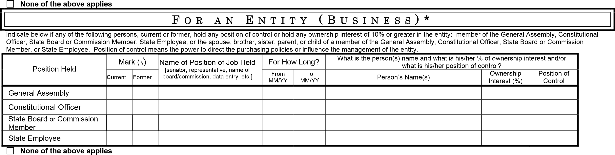

Contract and Grant Disclosure and Certification Form

Failure to make any disclosure required by Governor’s Executive Order 98-04, or any violation of any rule, regulation, or policy adopted pursuant to that Order, shall be a material breach of the terms of this contract. Any contractor, whether an individual or entity, who fails to make the required disclosure or who violates any rule, regulation, or policy shall be subject to all legal remedies available to the agency.

As an additional condition of obtaining, extending, amending, or renewing a contract with a state agency I agree as follows:

- Prior to entering into any agreement with any subcontractor, prior or subsequent to the contract date, I will require the subcontractor to complete a CONTRACT AND GRANT DISCLOSURE AND CERTIFICATION FORM. Subcontractor shall mean any person or entity with whom I enter an agreement whereby I assign or otherwise delegate to the person or entity, for consideration, all, or any part, of the performance required of me under the terms of my contract with the state agency.

- I will include the following language as a part of any agreement with a subcontractor:

Failure to make any disclosure required by Governor’s Executive Order 98-04, or any violation of any rule, regulation, or policy adopted pursuant to that Order, shall be a material breach of the terms of this subcontract. The party who fails to make the required disclosure or who violates any rule, regulation, or policy shall be subject to all legal remedies available to the contractor.

- No later than ten (10) days after entering into any agreement with a subcontractor, whether prior or subsequent to the contract date, I will mail a
copy of the CONTRACT AND GRANT DISCLOSURE AND CERTIFICATION FORM completed by the subcontractor and a statement containing the dollar amount of the subcontract to the state agency.
I certify under penalty of perjury, to the best of my knowledge and belief, all of the above information is true and correct and that I agree to the subcontractor disclosure conditions stated herein.

Signature___________________________________________Title____________________________Date_________________

Vendor Contact Person________________________________Title____________________________Phone No._________

Agency use only
Agency Agency Agency Contact Contract
Number______ Name___________________ Contact Person________________Phone No.___________ or Grant No._____

DOCUMENTATION CHECKLIST

As outlined in section 2.3 Minimum Qualifications in the solicitation document, please provide the following:

- Bidder must submit official documentation of active registration from the Arkansas Secretary of State’s Office.

- Bidder must provide a Certificate of Good Standing with bid submission.

- The Contractor must have at least two (2) current accounts, either commercial or government, providing staffing services. For verification purposes, bidder must provide a reference for these accounts with bid submission including the following information: organization name, address, contact person name, email address, and phone numbers.

- Bidder must submit all documents in the bid response packet including:
  - Bid Signature Page
  - Proposed Subcontractors Form
  - Vendor Agreement and Compliance
  - Official Bid Price Sheet

- Copy of Equal Opportunity Policy

- Bidder must submit signed/completed EO 98-08 Disclosure Form.

**Please refer to the solicitation (section 1.18 Response Documents) for additional instruction.**

.

