COVID-19 GUIDANCE FOR SELF HOME QUARANTINE
WHAT IS QUARANTINE?
Quarantine is an important way to stop the spread of COVID-19. It means staying home and away from others after you have been exposed to the virus that causes COVID-19. If you were in close contact with someone infected with COVID-19, this is considered an exposure.
QUARANTINE GUIDELINES FOR THE GENERAL PUBLIC
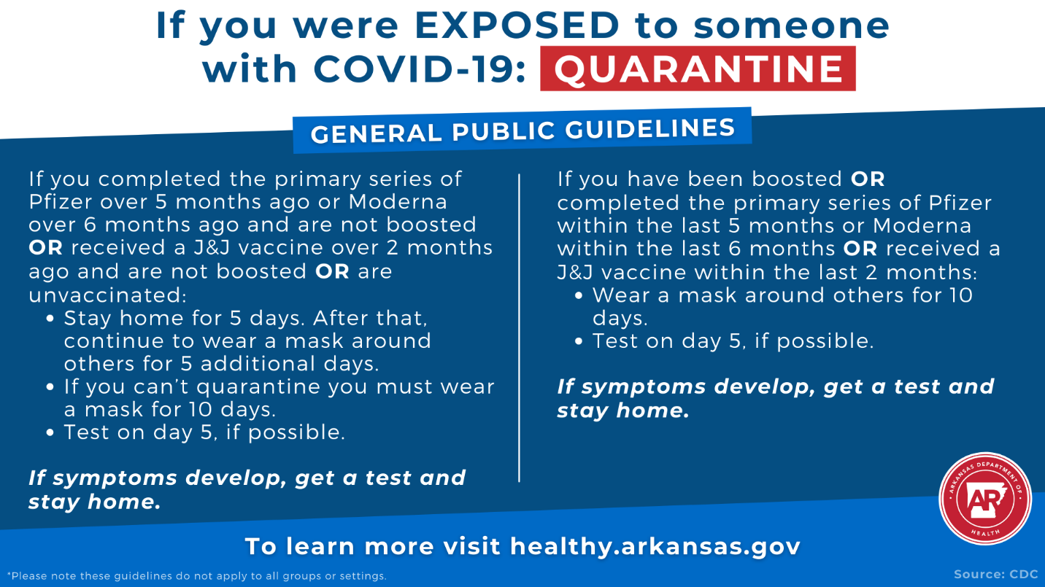
*Please note the above guidelines are for the general public. Guidelines for certain groups or settings may differ. For example, updated guidelines from CDC for K-12 schools, congregate settings, correctional facilities, and other groups have not been finalized.
PLEASE NOTE: The Arkansas Department of Health now recommends testing on Day 2 after exposure.
RESTRICTIONS DURING QUARANTINE
- Remain at home and avoid all public activities. These means do not go to work, church, school, stores (including grocery stores), nor any public events or places.
- Do not have visitors in your home.
- If you live in a home with other people, stay in a separate room. If that is not possible, wear a face mask when you are in the same room as others and stay at least 6 feet away from them (i.e. practice social distancing even in your home).
- Wash your hands and use an alcohol-based hand sanitizer often. Do not share personal items such as dishes, cups, forks, spoons, towels, etc.
- Do not leave your home except to get urgent or emergency medical care. If you need to see a doctor for reasons other than a medical emergency, please call your medical provider ahead of time to make proper arrangements.
- In the event of a medical emergency, call 911. Tell them that you are in home quarantine due to possible COVID-19 exposure. Keep a face mask on until a health care provider asks you to remove it. If you do not have a mask, use a folded kerchief or another similar device to cover your nose and mouth.
- Do not use any public transportation (buses, taxis, rideshare services, or airplanes).
- Check yourself for fever twice a day. This means taking your temperature in the morning and before bed at night and writing down the reading each time. The ADH will need this information to determine when you are able to resume normal activities or if you need additional care.
- If you begin to have symptoms such as fever, cough, or trouble breathing, or if you otherwise feel sick, contact your health care provider.

