COVID-19 GUIDANCE FOR SELF HOME ISOLATION
WHAT IS ISOLATION?
Isolation is for people who have been diagnosed with COVID-19. If you have COVID-19, being in isolation means you must stay home and away from others while you are infectious in order to stop the spread of the virus to anyone else.
ISOLATION GUIDELINES FOR THE GENERAL PUBLIC
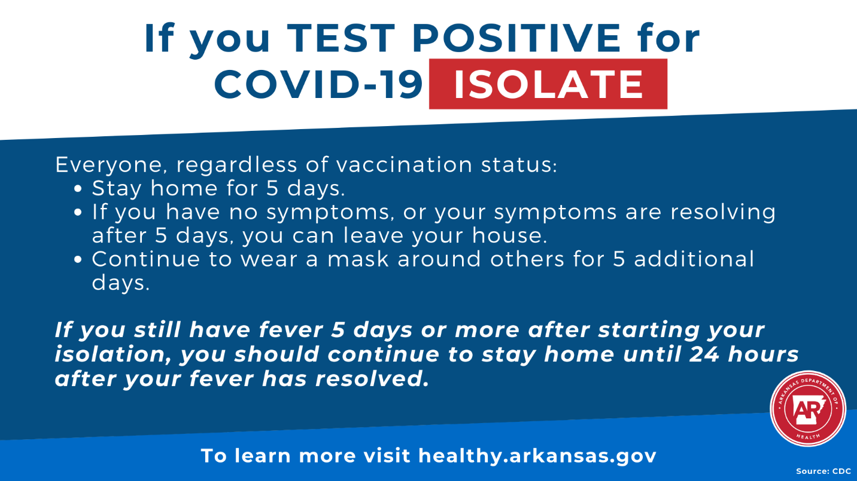
*Please note the above guidelines are for the general public. Guidelines for certain groups or settings may differ. For example, updated guidelines from CDC for K-12 schools, congregate settings, correctional facilities, and other groups have not been finalized.
RESTRICTIONS DURING ISOLATION
- Remain at home and avoid all public activities. These means do not go to work, church, school, stores (including grocery stores), nor any public events or places.
- Do not have visitors in your home.
- If you live in a home with other people, stay in a separate room. If that is not possible, wear a face mask when you are in the same room as others and stay at least 6 feet away from them (i.e. practice social distancing even in your home).
- Wash your hands and use an alcohol-based hand sanitizer often. Do not share personal items such as dishes, cups, forks, spoons, towels, etc.
- Do not leave your home except to get urgent or emergency medical care. If you need to see a doctor for reasons other than a medical emergency, please call your medical provider ahead of time to make proper arrangements.
- In the event of a medical emergency, call 911. Tell them that you are in home isolation due to a COVID-19 infection. Keep a face mask on until a health care provider asks you to remove it. If you do not have a mask, use a folded kerchief or another similar device to cover your nose and mouth.
- Do not use any public transportation (buses, taxis, rideshare services, or airplanes).
- Check yourself for fever twice a day. This means taking your temperature in the morning and before bed at night and writing down the reading each time.
- If you begin to have additional symptoms, or if you otherwise feel sick, contact your health care provider.

