CITY OF PINE BLUFF
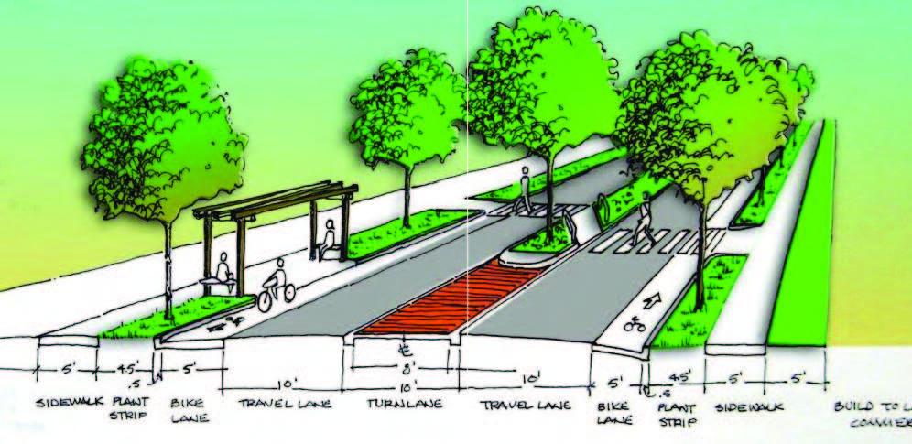
PLANNING COMMISSION
FEBRUARY 25TH, 2020 4:00 p.m.
City Council Chambers

AGENDA

CALL TO ORDER

CONSIDERATION OF MINUTES: January 28th, 2020

OLD BUSINESS:

NEW BUSINESS:

- Use Permit on Review request to establish all uses and height for Saracen Development, LLC at 3512 Market Street located in a B-3, Highway Commercial zone.

- Use Permit on Review request to build and establish a Fire Station at 3701 Market Street within a R-1, Residential zone.

3. Request to rezone approximately 5 acres at 3108 Oakwood Road from
R-1, Residential to I-1, Light Industrial.

COMMITTEE REPORTS: None

PLANNING DIRECTOR REPORT:

ADMINISTRATIVE MATTERS: None

OPEN DISCUSSION

ADJOURNMENT

