CITY OF PINE BLUFF
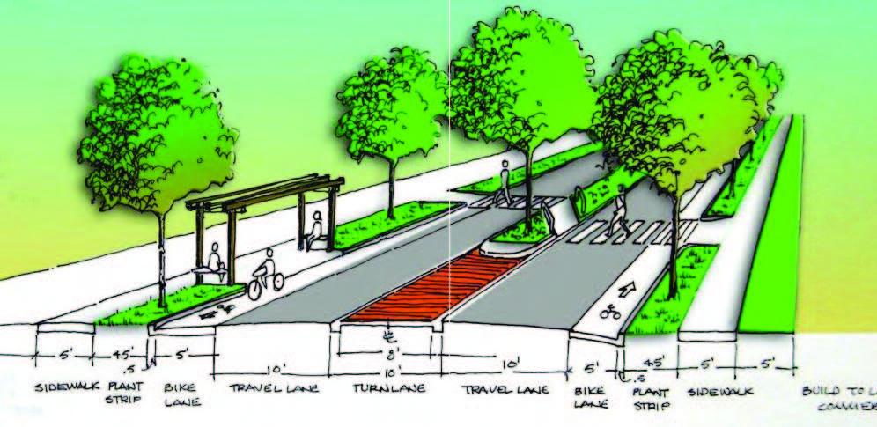
PLANNING COMMISSION
April 30TH, 2019 4:00 p.m.
City Council Chambers

AGENDA

CALL TO ORDER

CONSIDERATION OF MINUTES: March 26th, 2019

OLD BUSINESS:

1. Use Permit on Review request to establish a community vegetable or
flower garden at 1002 Indiana Street within a R-3, Residential zone.

2. Use Permit on Review request to establish a community vegetable or
flower garden at 1006 Indiana Street within a R-3, Residential zone.

3. Use Permit on Review request to establish a community vegetable or
flower garden at 2405 Reeker Street within a R-4, Residential zone.

4. Use Permit on Review request to establish a community vegetable or
flower garden at 2401 Reeker Street within a R-4, Residential zone.

5. Use Permit on Review request to establish a community vegetable or
flower garden at 2809 Whiteside Street within a R-3, Residential zone.

6. Use Permit on Review request to establish a church at 2809 Camden
Road within a B-3, Highway Commercial zone.

NEW BUSINESS:

7. Use Permit on Review request to establish a cigar lounge at 1520 S.
Main Street within a B-4, General Commercial zone.

8. Request to rezone the property located southwest of the intersection of
Hazel Street and Sheffield Drive from R-1, Residential to B-3, Highway
Commercial.

9. Street Closing request by Union Pacific Railroad to close a portion of
Maple Street between blocks G & H of James and Simpson Addition, a
portion of Maple Street between blocks 11 and 12 of Tannehill and
Owens Addition, a portion of Hickory Street between blocks E and F of
James and Simpson Addition, apportion of 5th Avenue between block F
and N located in James and Simpson Addition, a portion of 4th Avenue
between Plum Street and Spruce Street in the James and Simpson
Addition and a portion of the platted alley in block N and a part of the
East half of Cypress Street in James and Simpson Addition.

10. Amendment to Section 29 – Zoning as it relates to event centers.

CITY OF PINE BLUFF
PLANNING COMMISSION
April 30th, 2019 4:00 pm

continued

11. Amendments to Section – 22 – Signs and Advertising.

12. Review of Planning Commission Approval of a recycling center located
at 2315 W. 6th Avenue.

COMMITTEE REPORTS: None

PLANNING DIRECTOR REPORT: None

ADMINISTRATIVE MATTERS: None

OPEN DISCUSSION

ADJOURNMENT

Page 2 of 2

