2018
Pine Bluff-White Hall Metropolitan Planning Organization (MPO)
Southeast Arkansas Regional Planning
12/31/2018
A summary of Federal transportation obligations in the Pine Bluff-White Hall Metropolitan Planning Area between October 1, 2017 and September 30, 2018
Annual List of Obligated Projects (ALOP)

FY 2018 ANNUAL LISTING OF FEDERALLY OBLIGATED PROJECTS
Prepared by:
The Pine Bluff – White Hall Metropolitan Planning Organization (MPO)
Southeast Arkansas Regional Planning Commission

Prepared in cooperation with:
The Cities of Pine Bluff and White Hall
Jefferson County
Pine Bluff Transit
Arkansas Department of Transportation (ArDOT)
Federal Highway Administration (FHWA)
Federal Transit Administration (FTA)

SOUTHEAST ARKANSAS REGIONAL PLANNING COMMISSION
AND
PINE BLUFF AREA TRANSPORTATION STUDY
(PBATS)

NOTICE OF NONDISCRIMINATION:

The Southeast Arkansas Regional Planning Commission (SARPC) serving as the Pine Bluff Metropolitan Planning Organization (MPO) complies with the Disabilities Act of 1990, Section 504 of the Rehabilitation Act of 1973, Tile VI of the Civil Rights Act of 1964 all other federal equal opportunity laws and therefore does not discriminate on the basis of race, sex, color, age, national origin, religion, or disability in the admission or access to and treatment in SARPC and MPO programs and activities, as well as SARPC’s hiring or employment practices. Complaints of any alleged discrimination and inquiries regarding SARPC’s nondiscrimination policies may be directed to Larry Reynolds, Executive Director/MPO Study Director (ADA, 504, Title VI coordinator), 1300 Ohio, Suite B, Pine Bluff, AR 71601, telephone number (870) 534-4247 or the following email address: sarpc1@cablelynx.com.
This notice will be made available from the SARPC office in large print, on audiotape and in braille upon request. Free language assistance for Limited English Proficiency individuals is available upon request. For TTY assistance please call 870-461-0441.

The preparation and publication of this document was financed in part by funds provided by the United States Department of Transportation, Federal Highway Administration, Federal Transit Administration. The provisions of Federal financial assistance should not be construed as denoting U.S. Governmental approval of plans, policies, programs or projects contained herein.

Table of Contents
FY 2018 ANNUAL LISTING OF FEDERALLY OBLIGATED PROJECTS 1
NOTICE OF NONDISCRIMINATION: 1
ACRONYMS 3
What is the Pine Bluff – White Hall Metropolitan Planning Organization 4
Report Objective 5
Summary of Federal Transportation Obligations in FY 2018 5
Listing of Federal Highway Administration Obligated Projects FFY 2018 6
Listing of Federal Transit Administration Obligated Projects FFY 2018 7
Graphical Representations 8
APPENIX A: 2016-2020 PROJECT STATUS 10

ACRONYMS

ALOP Annual Listing of Federally Obligated Projects
ArDOT Arkansas Department of Transportation
CFR Code of Federal Regulations
Const Construction
FHWA Federal Highway Administration
FTA Federal Transit Administration
FY Fiscal Year (July 1 – June 30)
FFY Federal Fiscal Year (October 1 – September 30)
MPO Metropolitan Planning Organization
NHPP National Highway Performance Program
PBATS Pine Bluff Area Transportation Study
PBT Pine Bluff Transit
PE Preliminary Engineering
RTP Recreational Trails Program
SEARPC Southeast Arkansas Regional Planning Commission
SEAT Southeast Arkansas Transportation
STIP State Transportation Improvement Program
STP Surface Transportation Program
TAP Transportation Alternatives Program
TIP Transportation Improvement Program
U.S.C. United States Code

What is the Pine Bluff – White Hall Metropolitan Planning Organization
In 1974, SARPC was designated by the Governor as the Metropolitan Planning Organization (MPO) for transportation planning for the Pine Bluff Metropolitan Statistical Area. The formal name of the transportation planning program is the Pine Bluff Area Transportation Study (PBATS). The PBATS program was established in accordance with the Federal Highway Act of 1962, which required urban areas of more than 50,000 populations to create and maintain a continuing comprehensive transportation planning process carried on cooperatively by state and local communities in order to meet the transportation needs of public while complying with local, state and federal rules and guidelines. The PBATS area encompasses the cities of Pine Bluff, White Hall and portions of the unincorporated areas of Jefferson County that make up the Metropolitan Urbanized area as defined by the U.S. Census.
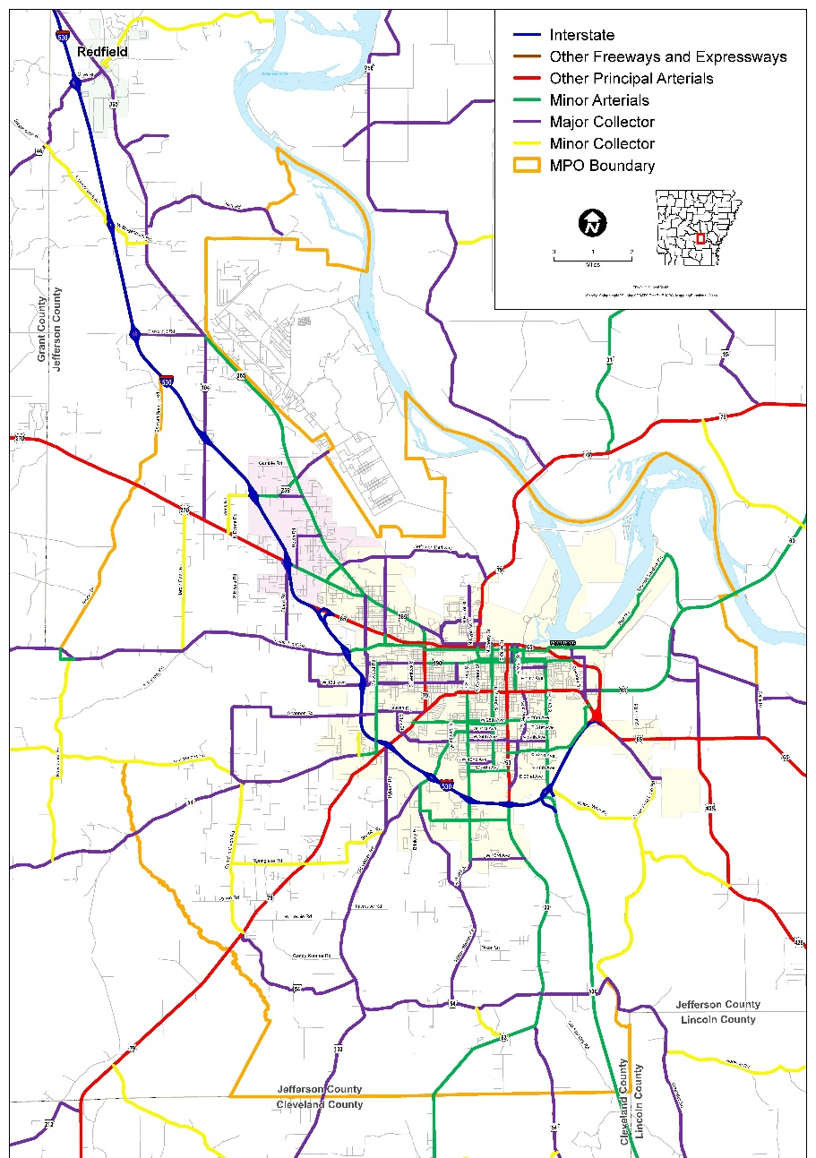

Report Objective
This report identifies projects in the Pine Bluff – White Hall Metropolitan Planning Area for which Federal funds were obligated between October 1, 2017 and September 30, 2018 (2018 Federal Fiscal Year). Obligation of funds reflects the Federal government’s commitment to pay or reimburse the State of Arkansas and/or local entities for the federal share of a project’s eligible costs. Obligation of funds does not necessarily imply that work on a project began in the year of obligation. Additionally, the amount of Federal funds obligated may not be equal to the total cost of a project, which may also include commitments from the State of Arkansas and local entities.

This report is published pursuant to 23 U.S.C. Section 134, 49 U.S.C. Section 5304, 23 CFR Section 450 and 49 CFR Section 613, which require the preparation of an annual list of projects for which Federal funds were obligated in the previous federal fiscal year. The list of FHWA obligated projects includes highway projects described by location, phase and the amount of Federal funds obligated; and the list of FTA obligated projects includes transit projects described by recipient, the type of assistance received and the amount of Federal funds obligated.
Transportation projects undertaken without the use of federal funds are not identified in either list.

Summary of Federal Transportation Obligations in FY 2018

As indicated in Table 1, between October 1, 2017 and September 30, 2018, the Federal government obligated approximately $ 29,235,778 for highway projects within the Pine Bluff – White Hall MPO area. Approximately $ 16,830,624 of those funds were committed to rehabilitation of I-530 from Highway 65B to Highway 65 with approximately $ 4,064,065 being allocated for reconstruction of Highway 65B (Martha Mitchell) from Bryant to Convention Center Drive. Transportation Alternative Program funding received $ 915,866 for a combination of Saracen Trail completion, White Hall Park Trail Improvement and UAPB Pedestrian Crossing. The remaining amount went toward engineering, consulting and utility relocation on other listed projects as shown in the table.

Table 2 shows Federal obligation to local transit operations for FFY 2018. Total obligations for the Pine Bluff – White Hall MPO area amounted to $ 1,458,781. This total represents an investment in capital equipment purchases of $731,627 with the remaining portion of
$ 727,154 allocated to transit operations, maintenance and paratransit service.

Listing of Federal Highway Administration Obligated Projects FFY 2018
PINE BLUFF PEDESTRIAN/BICYCLE INFRASTRUCTURE IMPROVEMENTS
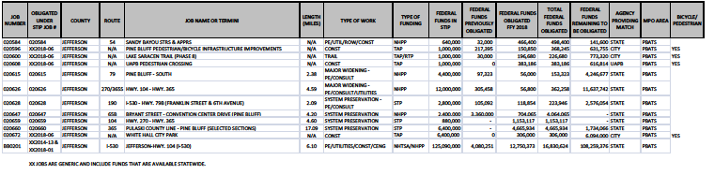

Listing of Federal Transit Administration Obligated Projects FFY 2018

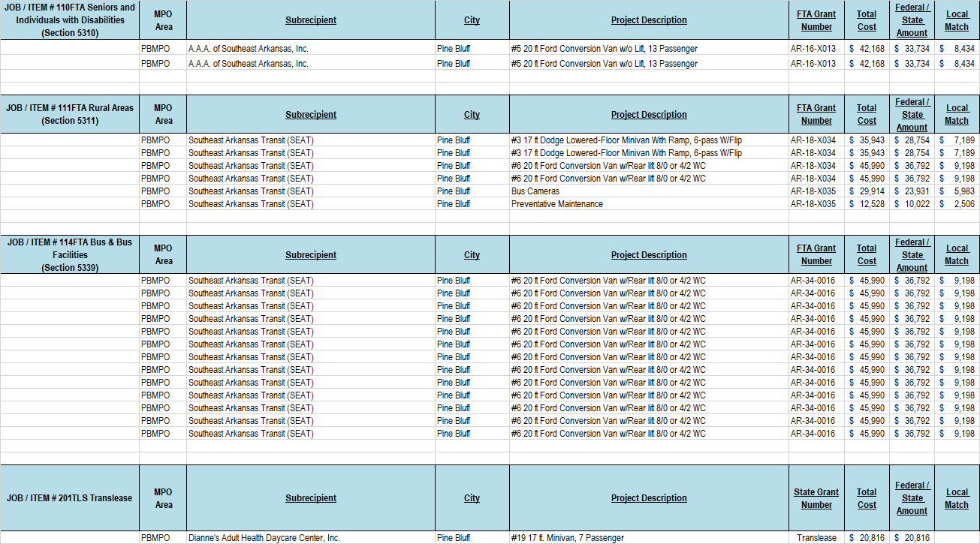

Graphical Representations

APPENIX A: 2017-2021 PROJECT STATUS

FY 2017-2021 Transportation Improvement Program (TIP) Project Status
Job # | County | Route | Name | Status
20070 | Jefferson | 79B | Hwy 6B North (Hwy 79B) | Under Construction
20584 | Jefferson | 54 | Sandy Bayou Strs & Apprs | Under Construction
20588 | Jefferson | 190 | 11th Ave.- Harding Ave | Design Phase
20600 | Jefferson | Trail | Lake Saracen Trail | Completed
20606 | Jefferson | Misc | Southwood Safe Route | Completed
20615 | Jefferson | 79 | Pine Bluff South | Design Phase
20626 | Jefferson | 270 / 365 Spur | Hwy 104 - Hwy 365 | Design Phase
20628 | Jefferson | 190 | I-530 -Hwy 79B (Franklin & 6th) | Design Phase
20647 | Jefferson | 65 | Bryant Str - Convention Center Dr | Under Construction
BB0202 | Jefferson | I-530 | Hwy 104 - Hwy 65B (I-530) | Completed
BB0203 | Jefferson | I-530 | Hwy 65B - Hwy 65 | Under Construction
02X041 | Jefferson | 63 | Pine Bluff Limits - south | Design Phase
S20202 | Jefferson | 79B | Caney Bayou – Arkansas River | Completed
02X051 | Jefferson | 104 | Hwy 270 – Hwy 365B | Completed

